FOR IMMEDIATE RELEASE
February 12, 2019
Contact: Lisa Jordan or Bill George
610.867.1689
lisa@touchstone.org or bill@touchstone.org

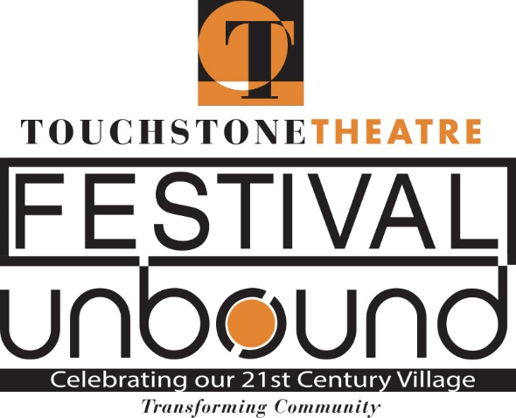
Touchstone Theatre Announces Festival UnBound

Touchstone Theatre, one of the country’s longest continuously producing ensemble theatres, will be producing a ten-day festival of original art and community conversation called Festival UnBound, October 4-13, 2019, in South Bethlehem and venues throughout the Lehigh Valley. This ten-day series of performances, installations, and happenings is created in collaboration with the people and artists of Bethlehem, visiting regional and international artists, and Bethlehem City government. Surrounding these events will be panel discussions, community meals, social media exchanges, and town meetings that will strive to find practical solutions for our city and the increased empathy and compassion that is necessary for us to advance collectively.

Starting in the Summer of 2016, Touchstone began a series of interviews and story gathering circles focused on addressing three questions:
- As a community, what changes and challenges are upon us now, and what are those we see coming?
- What will hold us together as we move forward?
- If we were to write the story of our future, what would we want it to be?
From these interviews and collected stories, hundreds of ideas and concerns sprang forth—many of them contradictory. Festival UnBound posits the question: what should we take with us into this uncertain and chaotic future? What would be better to leave behind?

From these hundreds of points of view, our three major themes emerged:
- The challenges and promise of diversity
- The health and interconnectedness of all things
- The importance of our youth
From these themes, dozens of projects for the Festival have been launched and continue to evolve.

Starting Friday, October 4, 2019, Festival UnBound will begin with an early evening Opening Ceremony on the Bethlehem Greenway just south of the Fahy Bridge and will parade to the amphitheater just north of Touchstone’s home at 321 E. 4th Street. From there, festival-goers may head down to the premiere of Prometheus Redux at the Lehigh Valley Charter High School for the Arts and see the sequel to Touchstone’s Steelbound of twenty years before; or they’ll have time for a meal at a local restaurant before heading back to Touchstone for an evening cabaret.

Before the Closing Ceremony on Sunday, October 13, presently planned for Payrow Plaza between City Hall and the Bethlehem Public Library, the Festival will offer over thirty performances of original work, four panel discussions, a forum on sustainability, a community dinner, lunch gatherings with the artists, and scores of “arts intersections” –-free public pop-up events created through collaborations between community organizations, Touchstone artists, and visiting international partners.

Planned events include:
- Opening and Closing Ceremonies: Outdoor music, drama, pageantry, and civic pride are brought together to initiate and close out this extraordinary festival.
- Homecoming: Voices of the African American community. Food, poetry, music, celebration of accomplishments, and questions as to where to next.
- Single Sisters: A dive into Bethlehem’s birth— amidst a Utopia of gender equality and cultural diversity— to recover the treasures and lessons of the past for our future. Sponsored in part by Sahl Communications.
- Youth Project: Youth from Bethlehem’s High Schools are being assembled to create an original, site-specific, multi-discipline work about their dreams and concerns for the future.
- Poets, Troubadours, & Troublemakers: Three evenings of original music dedicated to the Festival mission of envisioning our future home. A collaboration with Godfrey Daniels and singer-songwriter Anne Hills. Sponsored in part by the Lehigh Valley Engaged Humanities Consortium, with generous support provided by a grant to Lafayette College from the Andrew W. Mellon Foundation.
- A Joyful Noise: The Bach Choir and five community choirs celebrate our musical past and dreams for our diverse musical future. There will be singing en masse!
- Sustainability Forum: A gathering to debate and discuss how our community can best answer the challenges of maintaining a healthy and ever more connected community.
- Pregones Theatre Residency: The innovative voices of New York’s preeminent Latino theatre collective come to the Lehigh Valley for a residency with Bethlehem’s Latino population, collecting stories and songs to help lead us forward.
- Cabaret: Drinks, performances, and conversation at Touchstone’s home theatre -- a late-night watering hole where Festival attendees can meet and talk about the day’s events.
- The Kitchen Chronicles: Performances in a public kitchen where Mary Wright gives a delicious, one-of-a-kind take on the powers of food and wisdom shared in the kitchen. Sponsored in part by Morris Black and Channel 39.
- The Children’s Art Initiative: Bethlehem fourth graders create art inspired by our Festival questions: what kind of home do they wish to have here, and what might the future bring? Sponsored in part by Crayola and the Bethlehem Area School District, these art works will be featured throughout the Festival.
- Prometheus Redux: A sequel to Touchstone and Cornerstone’s Steel Festival classic. Where is Prometheus, twenty years after leaving the Steel, and what’s on his mind?
- Meet Me Halfway: Part theatrical happening, part block party, a symbolic and playful encouragement to “meet the other” halfway – planned for the Fahy Bridge.
- Agile Rascals Residency: Visiting eco-heroes and heroines who travel between performances on bicycles, advancing our appreciation and understanding of the planet.
- HD: We are proud to host the premiere of a new play by Mock Turtle Marionette Theater about the life and work of the Bethlehem born poet, Hilda Doolittle, the culmination of a year-long community partnership between Mock Turtle, Lehigh University English Department, Bethlehem Area Public Library and the Bradbury-Sullivan LGBT Community Center.
- Community Supper and Epilogue: A chance to break bread together while we talk and share our impressions and takeaways from the Festival experience.

Funding for Festival UnBound is ongoing, but to date, Festival sponsors include: The National Endowment for the Arts, The Northampton County General Purpose Authority, Lehigh University, PBS 39, Air Products, WDIY, Keystone Savings Foundation, Crayola, Bethlehem Public Library, Norris McLaughlin, The National Museum of Industrial History, Lehigh Valley Charter High School for the Arts, Imagevolution, Sahl Communications, Morris Black, Alvin H. Butz, Just Born, CADC Bethlehem, The Lehigh Valley Engaged Humanities Consortium, The Lehigh Valley Community Foundation, The Lesson Center, People’s Security Bank and Trust, The South Side Initiative, Moravian College, Ben Franklin Technology Partners, Ollie Foucek, Hillman Kraft Family Foundation, Bekah Eichelberger, and many others still to come.

Touchstone Theatre’s Festival UnBound takes place October 4-13, 2019. For more information, please contact Festival Coordinator Bill George, bill@touchstone.org
Festival UnBound website goes live February 25 at www.funbound.net
https://www.facebook.com/FestivalUnBound/
https://www.instagram.com/festivalunbound/
https://twitter.com/FestivalUnBound

